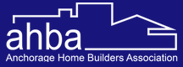  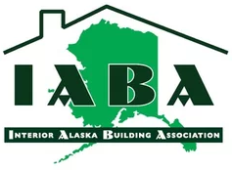  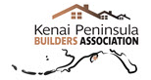  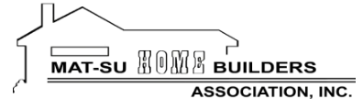  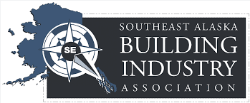  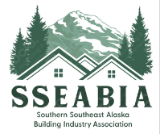 | 2026 Positions  - ASHBA supports state actions that promote a growing and diversified private sector in Alaska, and an expanded economic base through the responsible development of our natural resources. ASHBA supports a public messaging campaign communicating the economic impact of new housing across the state and the value it brings to the economy.  - ASHBA supports state funding to reduce the cost of housing, including funding for down payments, closing costs, interest rate buy-downs and through the Alaska Housing Finance Corporation’s New Home Construction Rebate Program.  - ASHBA supports continued state funding for the Alaska Housing Finance Corporation’s Weatherization Program to increase the energy efficiency of existing and newly constructed homes.  - ASHBA supports $500,000 in AHFC Corporate Dividends for housing construction, energy-efficiency analysis, and information dissemination among the housing industry and the public.  - ASHBA supports the state investing in high quality technical and vocational training opportunities, including trade training opportunities in high school to support Alaska’s high-demand careers and grow our home building industry.  - ASHBA supports HB 161 and SB 189 establishing exemptions for small business from paid sick leave requirements stemming from the passage of Ballot Measure 1 in 2024.  - ASHBA supports the adoption of a residential endorsement examination that reflects Alaska’s unique climate, soils, seismic risks, and building practices to ensure licensed builders are properly prepared to construct safe, durable, and energy-efficient homes in Alaska.  - ASHBA urges the Legislature to quickly approve the $70 million FY2026 match appropriation so Alaska’s federally funded transportation program remains on track to serve the needs of workers, businesses, and communities throughout the state.  - ASHBA opposes HB 224 establishing a volunteer labor compliance officer program.

